AA136A Winter 2023 -- Individual Assignment – Version B

Week 8: Commands and Telemetry

Summary
Let’s build on the IMU, Motor and Display understanding that you now have, and add the radio. You will learn how to packetize and decode both commands and telemetry. We will form teams of 2. Each team member will create both a ground station (GS) and a SATellite station. One individual deliverable is to demonstrate sending commands from the GS to the SAT which will change the motor speed. The deliverable checkoff procedure is:
- Discuss your team’s radio frequency with teams around you. 1 MHz between groups is fine. Set your frequency and show your TA.
- Make a list of the commands the satellite accepts(they are in dispatch_2 in Week_8.py)
- Person A will set their tripler to GS and Person B will set theirs to SAT.
- Issue one of the commands via the IMU or the command line. Tell your TA why you chose that command to try.
- Show your TA the path of the command through the GS and SAT serial terminals, and say whether the packet was ACK’d on the first transmission. Control-C to stop the activity and study/explain the outputs. Pointing and describing is the preferred method but certainly you can work from notes and screenshots.
- Then Person A will set their tripler to SAT and Person B will be the GS, and repeat 4 and 5.
- If there is a third person, they can be a traffic monitor when it’s not their turn to be either SAT or GS.

Obaining the Week_8_init and Week_8 python programs
Download these two programs from canvas, drag them onto your CIRCUITPY drive, and use Mu-editor to change code.py to include “import Week_8” in the first line. You will need to locate adafruit_gps.mpy, rfm69.mpy, lsm6ds folder and the asyncio folder and copy them to lib.

Introduction to the Hardware and Software
The IMU is used to generate a variety of commands like the week 3 Practical, except now the motor is remote from the IMU. A threshold of a minimum change before a command is sent limits the required command link bandwidth, but creates a deadband, whose extent you can control. (Having the IMU create commands is not a realistic scenario, but is very convenient for the class as it generates many commands quickly without tedious typing, and brings the system to life.)

The Radio, UART, I2C, and SPI (and other devices) can be operated as streams of bytes which can be grouped into packets (that word implies transmission) and buffers (that word implies the storage used to hold the data of the packet before or after sending).

The software uses queues for the receiver, transmitter, motor and for resending packets which didn’t get an acknowledgment, which is an ACK packet sent which confirms receipt of the first transmission.

A command is used to describe the content of the uplink, and telemetry is used to describe the content of the downlink. Most satellites also have a beacon, which sends a bit of telemetry autonomically on a periodic interval. (In this lab, and seldom in real life, the GS also has a beacon, as it provides information on the health of the GS.)

Optional Activities
1. From your list of the commands that the satellite can respond to, do you consider ACK a command? Why or why not?

2. Find the print statement that creates the BEACON transmission. What is it sending, and how might those values be useful to understand the flow and status?

3. How are commands and telemetry different from uploading a new program or downloading a data or log file? Which one benefits most from immediate ACKs and which one benefits most from bursts of packets which are ACK’d after the burst? Explore these two modes by commenting out one of these lines

Is yours a Satellite or Ground Station?
For the workshop, it’s convenient to use the same initialization for GS and SAT, and then you can make a single small change and switch from GS to SAT or back. The GS can also act as a channel monitor if the IMU-initiated commands are disabled, if there are 3 in your group.
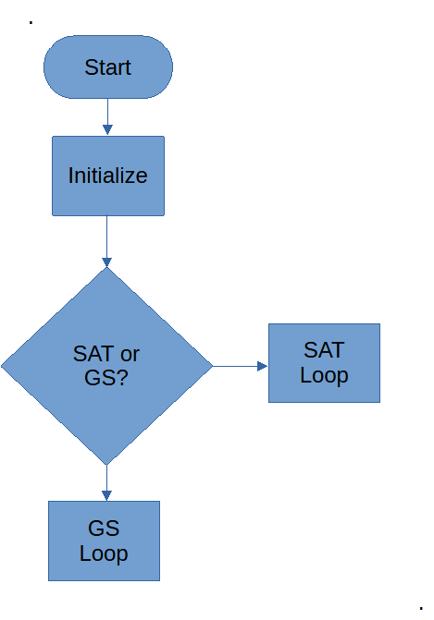
Figure 1. This structure allows you to easily change from GS to SAT with only a small change to your Workshop Program.
This is implemented in these lines:
SAT = False # True if running as SAT, False if running as GS

if (SAT):
print("**************************** SAT Loop ***************************")
.
.
.
else:
print("**************************** GS Loop ***************************")
.
.
.

Initialization is the same for both GS and SAT, and identical to prior labs for the IMU, motors and display. The radio initialization is new. The frequency is set, pins are allocated, the radio is reset and a test transmission is made.
print("**************************** Radio Initialize ***************************")
import adafruit_rfm69
import digitalio
RADIO_FREQ_MHZ = 915.0
spi = busio.SPI(board.SCK, MOSI=board.MOSI, MISO=board.MISO)
cs = digitalio.DigitalInOut(board.D5)
reset = digitalio.DigitalInOut(board.D6)
rfm69 = adafruit_rfm69.RFM69(spi, cs, reset, RADIO_FREQ_MHZ)
rfm69.send(bytes("Hello world!\r\n", "utf-8"))

There may be times when you need to pick a frequency different from other stations in the lab.

Supporting Activities (required)
- Arrange yourselves in pairs. Decide who will be the GS and who the SAT. Edit the program with Mu-editor to make the change.
- If there are three in your group, have 2 ground stations, and one of them should have the rfm69.send commands in transmit_2 commented out with a #.
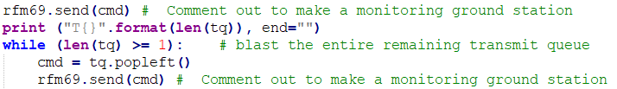

- You and your team mates may choose another frequency from 902 to 928 MHz. Using Mu-editor, what line would you change, and to what?

Optional Activities
- Observe the RF waterfall on the SDR. If you continuously move the ground station, which queues a lot of transmissions in burst mode, does the transmitter create a radio signal continuously? Add “rfm69.bitrate = 500” to radio initialization for this.
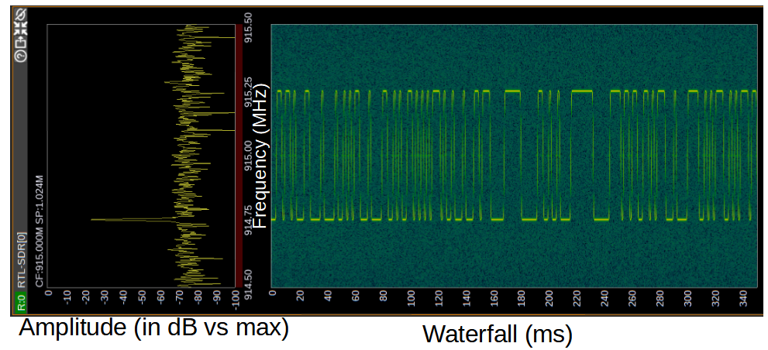
Figure 2. RTL-SDR hardware and SDRAngel software showing the signals being sent

Satellite command dispatch
The SAT will send a beacon periodically with some identifying information. The dispatcher detects which command is received.
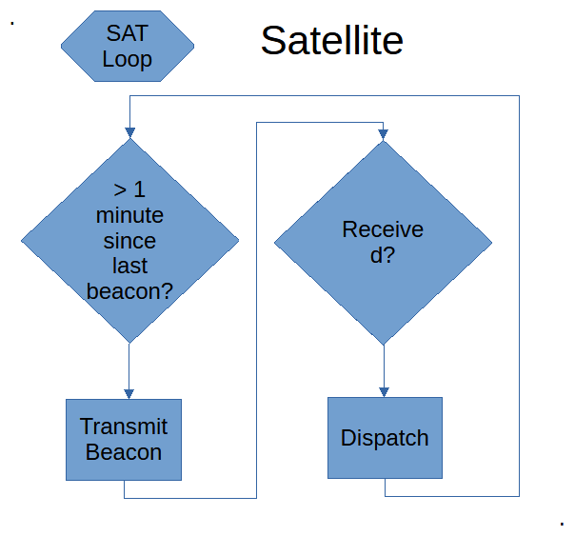
Figure 3. The SAT receives commands and dispatches them (decode and execute them if possible), and periodically sends a beacon.

Here’s the satellite loop program in the simplest non-concurrent case
SAT = True # True if running as SAT, False if running as GS

if (SAT):
print("**************************** SAT Loop ***************************")
while (1):
# Read the GPS
# Time for a beacon?
if (time.monotonic() > last_beacon):
last_beacon = time.monotonic() + Beacon_Period
rfm69.send(bytes("BEACON: Hello world!\r\n", "utf-8"))
# Did we receive something?
packet = rfm69.receive(timeout=0.1)
if packet is None:
break
else:
# Received a packet!
packet_text = str(packet, "ascii")
print("{0}".format(packet_text, end=""))
# Dispatch it
if (packet_text == "NOOP"):
exec_cmd_cnt += 1
elif (packet_text == "STOP"):
exec_cmd_cnt += 1
speed = 0
kit.motor1.throttle = speed
if (packet_text == "EXEC"):
exec_cmd_cnt += 1
speed = int(packet_text[5:10])
kit.motor1.throttle += speed
if (packet_text == "HK"):
exec_cmd_cnt += 1
rfm69.send(bytes("TELEMETRY: Hello world!\r\n", "utf-8"))
if (packet_text == "DISP"):
exec_cmd_cnt += 1
text_4 = label.Label(terminalio.FONT, text=packet_text[5:], color=0x000000, x=10, y=47)
splash.append(text_4)
else:
bad_cmd_cnt += 1

Optional Activities
- Design and add a command of your own invention to the dispatch and try it out
- Add something reported by the beacon
- What information would be useful on the display? How would you add it?
- Adjust the deadband to see its effect on radio traffic.
- Change the beacon period to 10 seconds and confirm from the Serial window that it changed.

Send commands and receive telemetry via the serial window in Mu-editor
The commands can come from the IMU, which will increment/decrement the speed of the motor depending on the accelerometer. This is a workshop expediency, it connects to the prior labs and generates a lot of commands quickly without tedious typing.
All commands can be executed from the Serial window of Mu-editor.
And if the satellite sends a packet, your GS program will figure out if it’s a Beacon or Telemetry and print appropriately on the GS serial window.

Optional Activities
- Try all the commands and see if the commanded module (the satellite) operates correctly. What do you expect? What does it do? For no-op, see if the count of executed commands is incremented, by requesting HK before and after the NOOP.
Here’s the ground station loop program in the simple non-concurrent case.
else:
print("**************************** GS Loop ***************************")
while (1):
# Read the IMU now
xn, yn, zn = [val / adafruit_lis3dh.STANDARD_GRAVITY for val in lis3dh.acceleration]
print("x = %0.3f G, y = %0.3f G, z = %0.3f G" % (xn, yn, zn))
# Did it change by enough to trigger a transmission?
if (xn - x > acc_thresh):
x = xn; y = yn; z = zn
rfm69.send(bytes("EXEC\r\n".format({xn}), "utf-8"))
# Did GS operator type in a command? Send it
if supervisor.runtime.serial_bytes_available:
rfm69.send(bytes(input().strip(), "utf-8"))
# Did we receive a packet from the Satellite?
packet = rfm69.receive(timeout=0.1)
if packet is None:
break
else:
# Received a packet!
packet_text = str(packet, "ascii")
#print("Received (ASCII): {0}".format(packet_text), end="; ")
print("{0}".format(packet_text, end=""))
# Is it a Beacon or Telemetry?
if (packet_text == "BEACON"):
print(packet_text)
elif (packet_text == "TELEMETRY"):
print(packet_text)

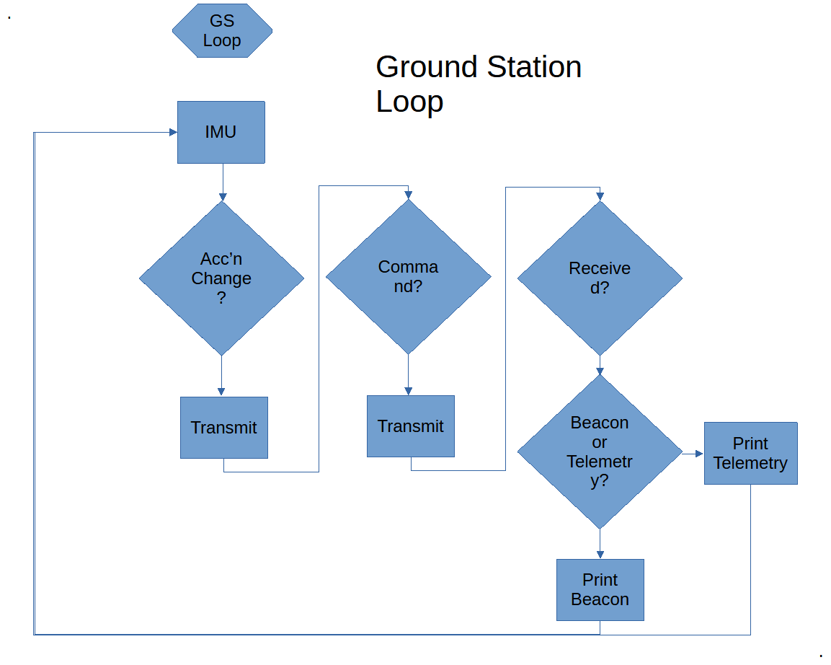
Figure 4. The ground station can generate commands which effectively “remote” the motors from the IMU, or any command, and will print Telemetry and the Beacon.

Co-routines
Satellites and Ground stations need to do a number of things “at the same time”. But there is only one processor core, and in an embedded (small) system, only one thread. In the first section, we saw that when listening for a packet, all other operations are stopped. Similarly, when the IMU is being read or the motors moved, we are not listening. In real life, this is an issue, as packets may be missed. The solution is in the library asyncio, which allows multiple loops to run at the same time, each one can work until it needs to wait for the hardware (to receive something, or finish moving the motor). During the wait, Python executes a different loop. There is an effect of simultaneous multiple operations. The relative priority of each task can be controlled by a longer or shorter sleep period.

Computer Terminology
An embedded system is a small computing system with a dedicated function, like a satellite, and unlike a laptop which is general-purpose.
A processor (often said “processor core”) is a device which can store and recall data and programs from memory, and perform math and logical operations on them.
Most modern laptops have multiple cores, but on a satellite and other embedded systems, usually there is one core.
One core runs one thread at a time. A thread is a portion of a program or sometimes the entire program, depending on the software designer’s decisions. In Windows, Task Manager shows the number of threads in task manager. On a Mac, it is in Activity Monitor. This number gives an indication of the complexity of the programs the laptop is managing.
Ascyncio is a small-system version of multi-tasking like found in a laptop allowing the appearance of multiple threads on a single small processor. Instead of threads, they are called co-routines.
Priority of a thread controls how much time a thread is given.
The flowcharts are different now with asyncio co-routines, with multiple loops shown that take care of the various tasks. Since they are nearly all infinite loops, the event loop (as it’s called) never completes. One way that they are different is that there are queues which store received packets, to-be-transmitted packets, and motor moves. Also to transmit, the receiver needs to be turned off, and a “lock” is shared between the receiver and transmitter as there is only one radio.
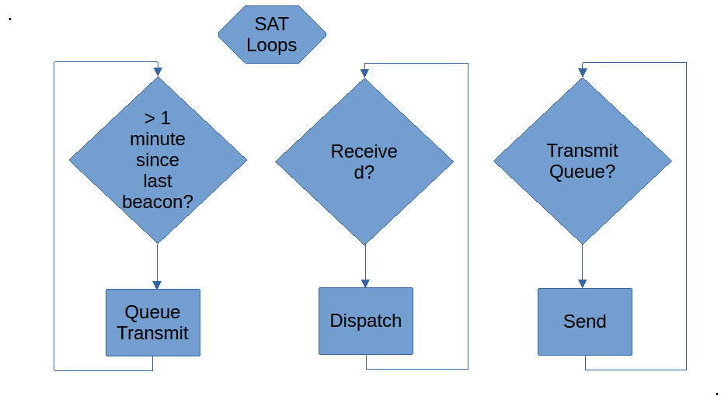
Figure 5. The satellite asyncio structure includes queues for transmit, allowing multiple tasks to transmit and draw from the receiver queue while the receive and transmit tasks use a lock.

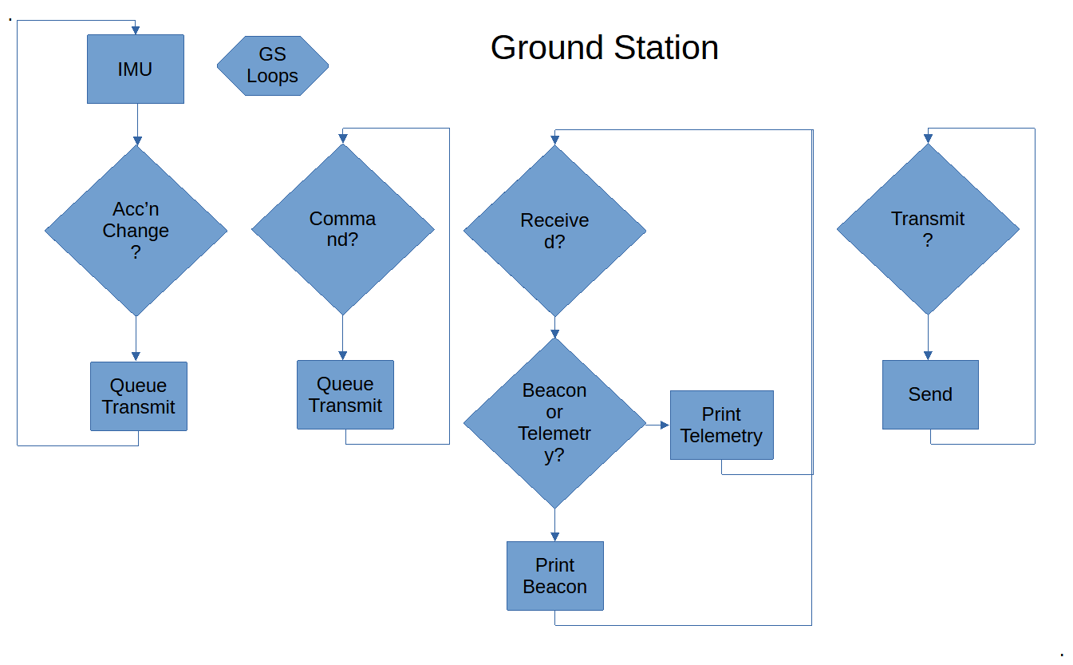
Figure 6. The Ground Station async loops, like the SAT async loops, run concurrently.
Queues are used to separate the loops with substantial waits for hardware. For example, the receiver doesn’t use the rfm69 library but instead talks to the chip directly, to set it into receive mode and come back later (when other loops have a spare moment) to check if something was received. Thus, the receiver can be on much more of the time, and less likely to miss packets.

Still, some packets can be lost. A queue is used to store sent packets (Sent, not acknowledged queue, snaq). When the ACK is received, the packet is removed from snaq. Packets still in snaq are resent.
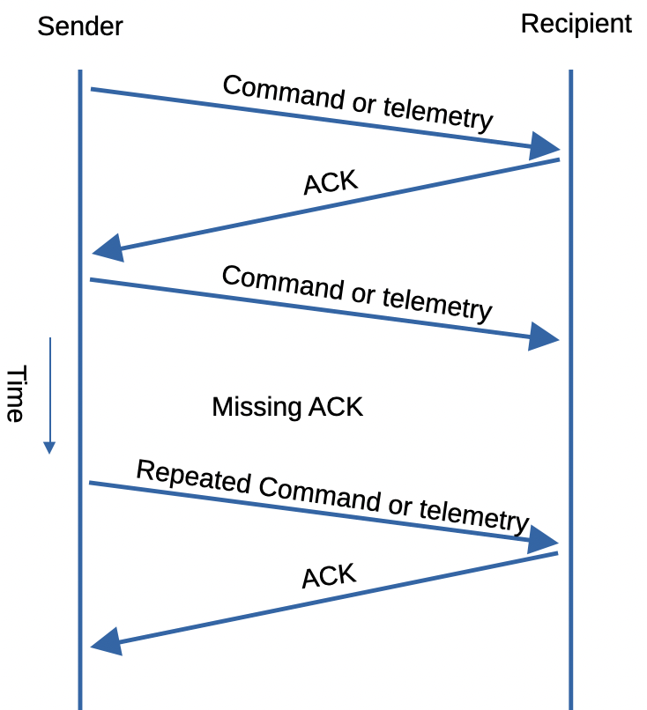

Figure 7. Radio Packet sequence for a completed exchange (top) a missing ACK (middle) and a resend.

Optional Activities
- Identify the statements that implement the queue. Why is the snaq que different?
- Identify the statements that resend missing packets.
- Create a new task that resets the packet serial number when it gets too large. Hint: Create the function, initiate it as a task in the loop, and add it to the “gather” list.
- Create a flood of commands by steadily moving the IMU in burst mode. What happens when the queues fill up? Monitor the queue capacity by noting the messages in the beacon. You can also initiate the same message with the “HK” housekeeping command.
- Are the beacons ACK’d? Are the ACKs ACK’d? Does the recipient know that the sender got the ACK? Does the sender know that the recipient knows that the sender knows the ACK was received?

